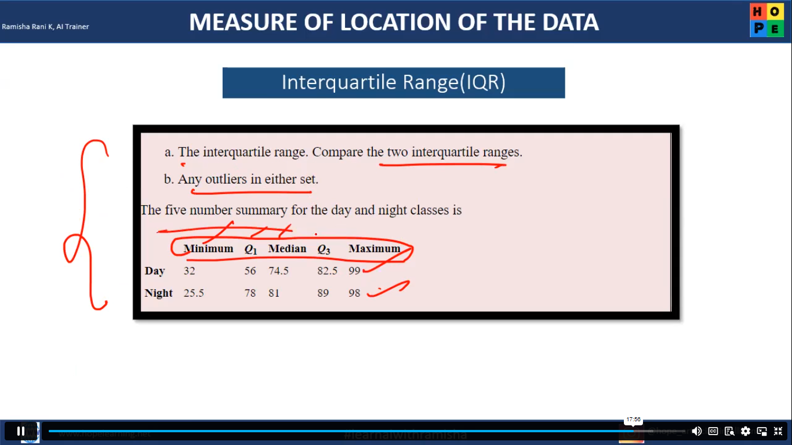

**Calculation Summary:**

1. **Quartiles and IQR Calculation:**

* **Q1** = 56
* **Q3** = 82.5
* **IQR** = Q3 - Q1 = 82.5 - 56 = 26.5

1. **Lesser and Greater Outlier Calculation:**

* **Lesser Outlier** = Q1 - 1.5 * IQR  
  = 56 - 1.5 * 26.5  
  = 56 - 39.75  
  = **16.25**
* **Greater Outlier** = Q3 + 1.5 * IQR  
  = 82.5 + 1.5 * 26.5  
  = 82.5 + 39.75  
  = **122.25**

1. **Range for Identifying Outliers:**

* Outliers are any values below **16.25** or above **122.25**.

1. **Checking the "Day" and "Night" Values:**

* **Day:**
  + Minimum = 32
  + Maximum = 99
* **Night:**
  + Minimum = 25.5
  + Maximum = 98

**Conclusion:**

* All "Day" and "Night" values (minimum and maximum) fall within the range of **16.25** (Lesser Outlier) to **122.25** (Greater Outlier).
* **There are no outliers** in this dataset based on the IQR method, as all values lie within the acceptable range.